|  |  |  |  |  |  |
| --- | --- | --- | --- | --- | --- |
| **Attribute**  **Name** | **Sample**  **Value** | **Sample**  **Value** | **Sample**  **Value** | **Sample**  **Value** | **Sample**  **Value** |
| INV_NUM | 211347 | 211347 | 211347 | 211348 | 21349 |
| PROD_NUM | AA-E3522QX | QD-300932X | RU-995748G | AA-E3522QW | GH-77834SP |
| SALE_DATE | 15 Jan-2018 | 15 Jan-2018 | 15 Jan-2018 | 15 Jan-2018 | 16 Jan-2018 |
| PROD_LABEL | Rotary sander | 0.25-in. Drill bit | Band saw | Rotary sander | Power drill |
| VEND_CODE | 211 | 211 | 309 | 211 | 157 |
| VEND_NAME | NeverFall,  inc | NeverFall,  inc | BeGood,  inc | NeverFall,  inc | ToughGo,  inc |
| QUANT_SOLD | 1 | 8 | 1 | 2 | 1 |
| PROD_PRICE | $34.46 | $2.73 | $31.59 | $34.46 | $69.32 |

N1

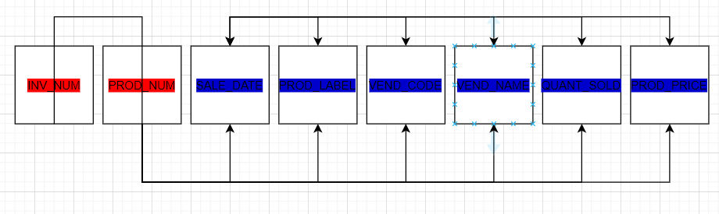

N2

Product Name: Item

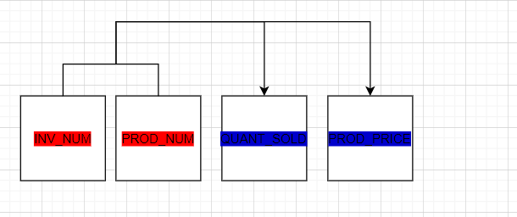

Product Name: Product

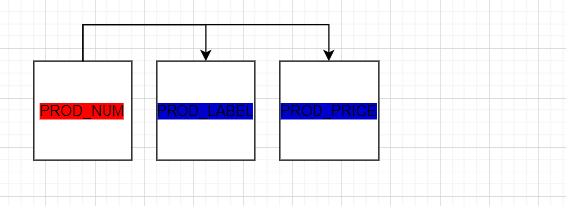

Product Name: Invoice

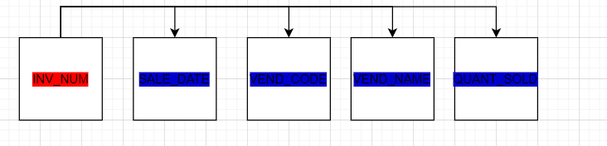

N3

Product Name: Item



Product Name: Product



Product Name: Invoice

